**🌟 SQL Query Documentation 🌟**

This document contains a collection of SQL queries along with their explanations. Each query is designed to extract meaningful insights from the **MXMH Survey Dataset**(spotify_app).

**1. Average Daily Music Hours by Streaming Service**

**Explanation:**  
This query calculates the average number of hours per day users spend listening to music, grouped by their primary streaming service (Spotify, Apple Music, etc.).

**SQL Query:**

SELECT primary_streaming_service, AVG(hours_per_day) AS avg_hours

FROM spotify_app

GROUP BY primary_streaming_service

ORDER BY avg_hours DESC;

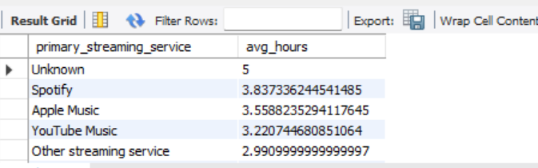

**2. Most Popular Favorite Genres**

**Explanation:**  
This query counts how many users selected each favorite genre, showing which music genre is the most loved among survey participants.

**SQL Query:**

SELECT fav_genre, COUNT(*) AS total_fans

FROM spotify_app

GROUP BY fav_genre

ORDER BY total_fans DESC;

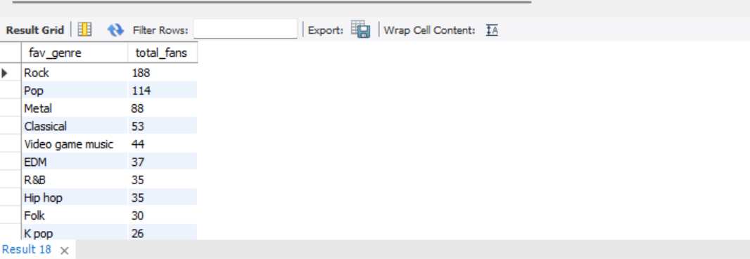

**3. Average Anxiety Level by Genre**

**Explanation:**  
This query calculates the average anxiety score for listeners of each genre, helping us understand which music fans experience more anxiety.

**SQL Query:**

SELECT fav_genre, AVG(anxiety) AS avg_anxiety

FROM spotify_app

GROUP BY fav_genre

ORDER BY avg_anxiety DESC;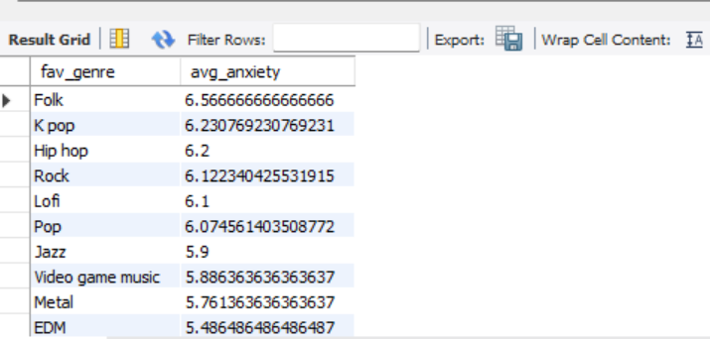

**4. Insomnia Level by Streaming Service**

**Explanation:**  
This query determines the average insomnia score among users of each streaming service to identify if certain platforms are linked to more sleepless nights.

**SQL Query:**

SELECT primary_streaming_service, AVG(insomnia) AS avg_insomnia

FROM mxmh_survey_cleaned

GROUP BY primary_streaming_service

ORDER BY avg_insomnia DESC;

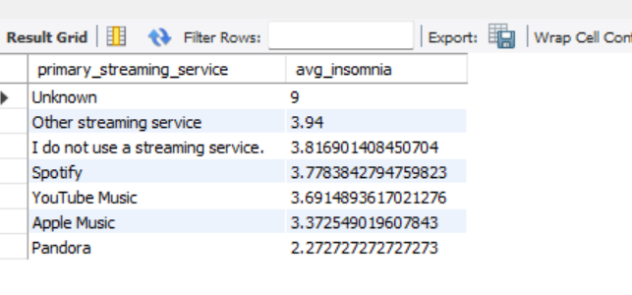

**5. OCD Average by Genre**

**Explanation:**  
This query finds the average OCD scores among fans of different genres to check if certain genres attract more obsessive listeners.

**SQL Query:**

SELECT fav_genre, AVG(ocd) AS avg_ocd

FROM mxmh_survey_cleaned

GROUP BY fav_genre

ORDER BY avg_ocd DESC;

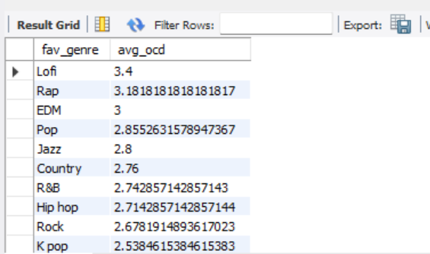

**6. Listening Habits While Working**

**Explanation:**  
This query counts how many people listen to music while working versus those who don’t, revealing common productivity habits.

**SQL Query:**

SELECT while_working, COUNT(*) AS count_users

FROM mxmh_survey_cleaned

GROUP BY while_working;

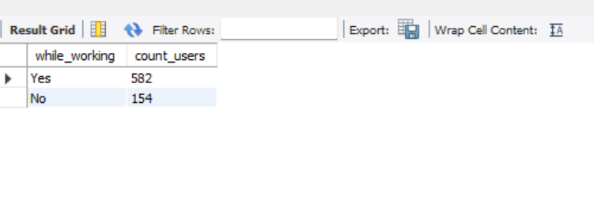

**7. Top BPM Genres**

**Explanation:**  
This query calculates the average beats per minute (BPM) for each genre to discover which genres have faster rhythms.

**SQL Query:**

SELECT fav_genre, AVG(bpm) AS avg_bpm

FROM mxmh_survey_cleaned

GROUP BY fav_genre

ORDER BY avg_bpm DESC;

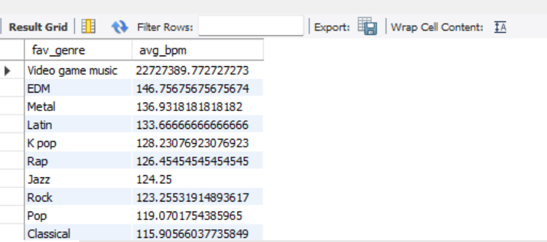

**8. Survey Entries Over Time**

**Explanation:**  
This query shows how many responses were recorded on each date, helping track survey participation trends over time.

**SQL Query:**

SELECT DATE(timestamp) AS date, COUNT(*) AS entries

FROM mxmh_survey_cleaned

GROUP BY DATE(timestamp)

ORDER BY date;

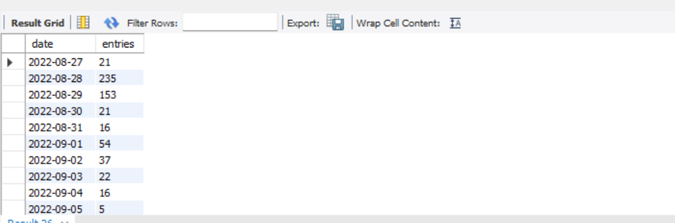

**9. Music Effect on Mood**

**Explanation:**  
This query counts how users feel their mood changes due to music, whether it improves, worsens, or remains unaffected.

**SQL Query:**

SELECT music_effects, COUNT(*) AS count_effects

FROM mxmh_survey_cleaned

GROUP BY music_effects;

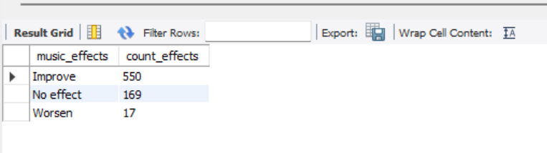

**10. Favorite Genre Among Instrumentalists**

**Explanation:**  
This query identifies the most popular genres among users who play musical instruments.

**SQL Query:**

SELECT fav_genre, COUNT(*) AS instrumentalist_count

FROM mxmh_survey_cleaned

WHERE instrumentalist = 'Yes'

GROUP BY fav_genre

ORDER BY instrumentalist_count DESC;

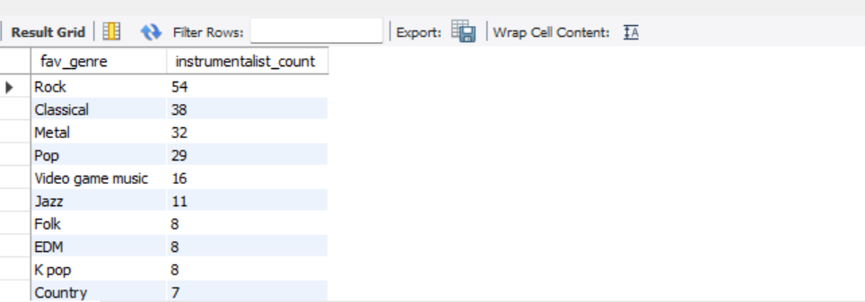

**11. Exploratory Listeners Genre Choice**

**Explanation:**  
This query shows the favorite genres among users who like exploring new music.

**SQL Query:**

SELECT fav_genre, COUNT(*) AS explorer_count

FROM mxmh_survey_cleaned

WHERE exploratory = 'Yes'

GROUP BY fav_genre

ORDER BY explorer_count DESC;

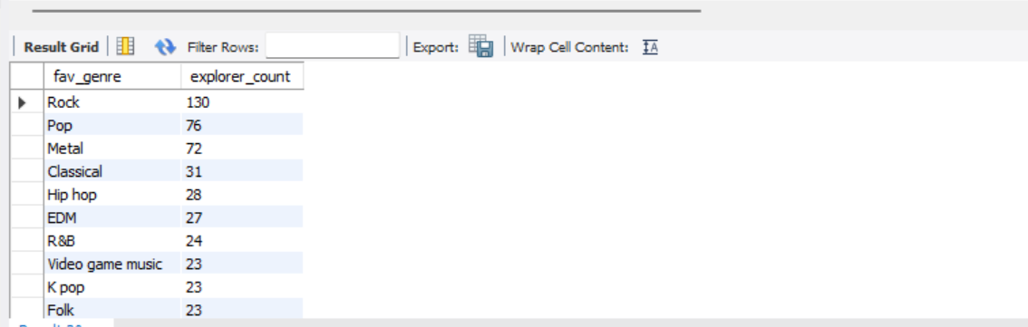

**12. Foreign Language Listeners' Top Genre**

**Explanation:**  
This query highlights the favorite genres among users who enjoy listening to music in foreign languages.

**SQL Query:**

SELECT fav_genre, COUNT(*) AS foreign_lang_listeners

FROM mxmh_survey_cleaned

WHERE foreign_languages = 'Yes'

GROUP BY fav_genre

ORDER BY foreign_lang_listeners DESC;

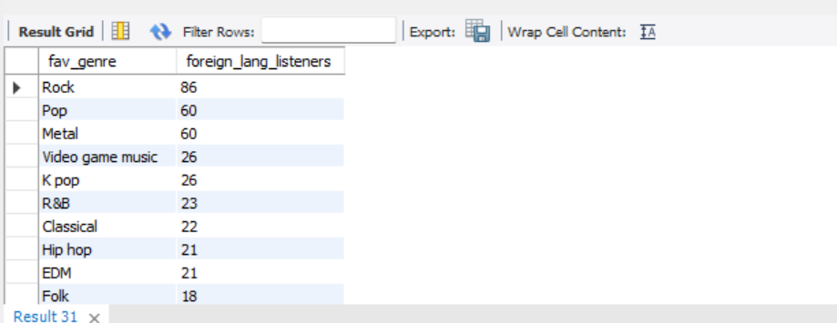

**13. High Depression vs Low Depression Listeners**

**Explanation:**  
This query categorizes users into 'High Depression' and 'Low Depression' groups based on their depression scores, and counts them.

**SQL Query:**

SELECT CASE

WHEN depression >= 7 THEN 'High Depression'

ELSE 'Low Depression'

END AS depression_category,

COUNT(*) AS user_count

FROM mxmh_survey_cleaned

GROUP BY depression_category;

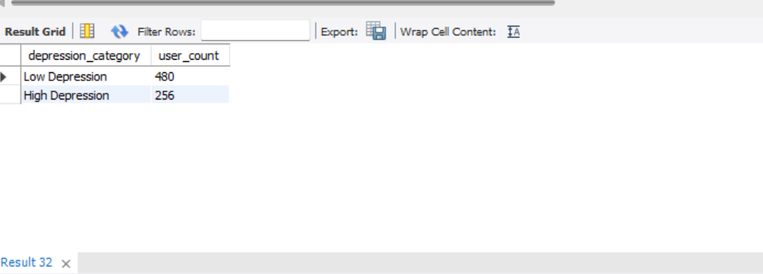

**14. Top Genres for "Very Frequent" Rock Listeners**

**Explanation:**  
This query identifies other favorite genres among users who listen to rock music very frequently.

**SQL Query:**

SELECT fav_genre, COUNT(*) AS rock_heads

FROM mxmh_survey_cleaned

WHERE frequency_rock = 'Very frequently'

GROUP BY fav_genre

ORDER BY rock_heads DESC;

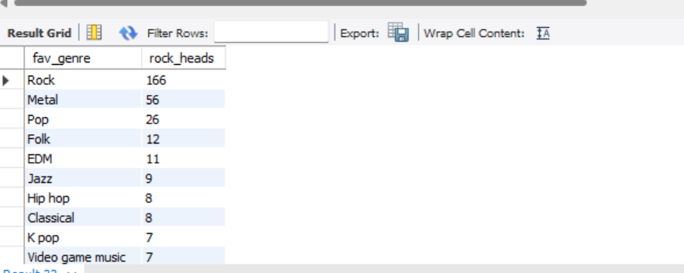

**15. Gamers' Favorite Genre**

**Explanation:**  
This query finds the top genres preferred by users who frequently listen to video game music.

**SQL Query:**

SELECT fav_genre, COUNT(*) AS gamer_fans

FROM mxmh_survey_cleaned

WHERE frequency_video_game_music = 'Very frequently'

GROUP BY fav_genre

ORDER BY gamer_fans DESC;

